ZARA SALES ANALYSIS

Data Analysis Project

Prepared By:
Rakesh Gope

Tools Used:
Python | BigQuery SQL | Power BI

Date:
June 2026

Contents
1. Introduction 4
2. Business Problem Statement 4
Business Question 4
3. Project Objectives 4
4. Dataset Overview 5
Key Attributes 5
5. Data Preparation (Python) 5
Data Cleaning 5
Data Quality Checks 6
Feature Engineering 6
6. SQL Analysis (BigQuery) 7
Analyses Performed 7
Top-Selling Products 7
Promotion Effectiveness 7
Product Position Analysis 7
Seasonal Analysis 8
Product Category Analysis 8
Section Analysis 8
7. Power BI Dashboard 9
Dashboard Components 9
KPI Cards 9
Interactive Filters 9
Visualizations 9
8. Key Findings 10
1. Top Product Performance 10
2. Promotion Impact 10
3. Product Position Performance 10
4. Seasonal Analysis 10
5. Product Category Performance 10
6. Section Performance 10
9. Business Recommendations 11
Product Strategy 11
Merchandising 11
Promotion Strategy 11
Inventory Planning 11
Customer Segmentation 11
10. Conclusion 11
Technologies Used 12
Project Deliverables 12

Zara Sales Analysis Project Report

1. Introduction
Retail companies rely heavily on sales data to understand customer preferences, optimize product placement, and improve overall business performance. This project focuses on analyzing Zara's product sales dataset to identify key sales trends, evaluate promotion effectiveness, and understand product performance across different categories and store positions.
The project combines Python for data preparation, SQL (BigQuery) for data analysis, and Power BI for dashboard visualization. The insights generated can support data-driven decision-making related to product strategy, promotions, and inventory planning.

2. Business Problem Statement
Zara aims to better understand product sales performance and customer purchasing trends. The company wants to identify factors influencing sales volume, evaluate the effectiveness of promotional activities, and determine which product categories and store placements contribute most to revenue generation.

Business Question
How can Zara leverage sales data to identify trends, improve product performance, and optimize marketing and merchandising strategies?

3. Project Objectives
The primary objectives of this project are:
- Clean and prepare the sales dataset for analysis.
- Analyze product sales performance across categories and sections.
- Evaluate the impact of promotional activities on sales volume.
- Identify top-performing products and categories.
- Examine the influence of product placement on sales.
- Build an interactive dashboard for business stakeholders.
- Generate actionable recommendations based on data insights.

4. Dataset Overview
The dataset contains product-level sales information collected from Zara's online product catalog.

Key Attributes
- Product ID
- Product Name
- Product Category
- Sales Volume
- Promotion Status
- Seasonal Status
- Product Position
- Section (Men/Women)
- Brand
- SKU
- Description
- Scraped Date
Total Products Analyzed: 250

5. Data Preparation (Python)
The following data preparation steps were performed using Python:

Data Cleaning
- Loaded dataset into Pandas DataFrame.
- Checked dataset structure and data types.
- Identified missing values.
- Removed records with missing product names and descriptions.
- Converted scraped_at column into datetime format.
- Standardized column names.
- Verified data consistency.
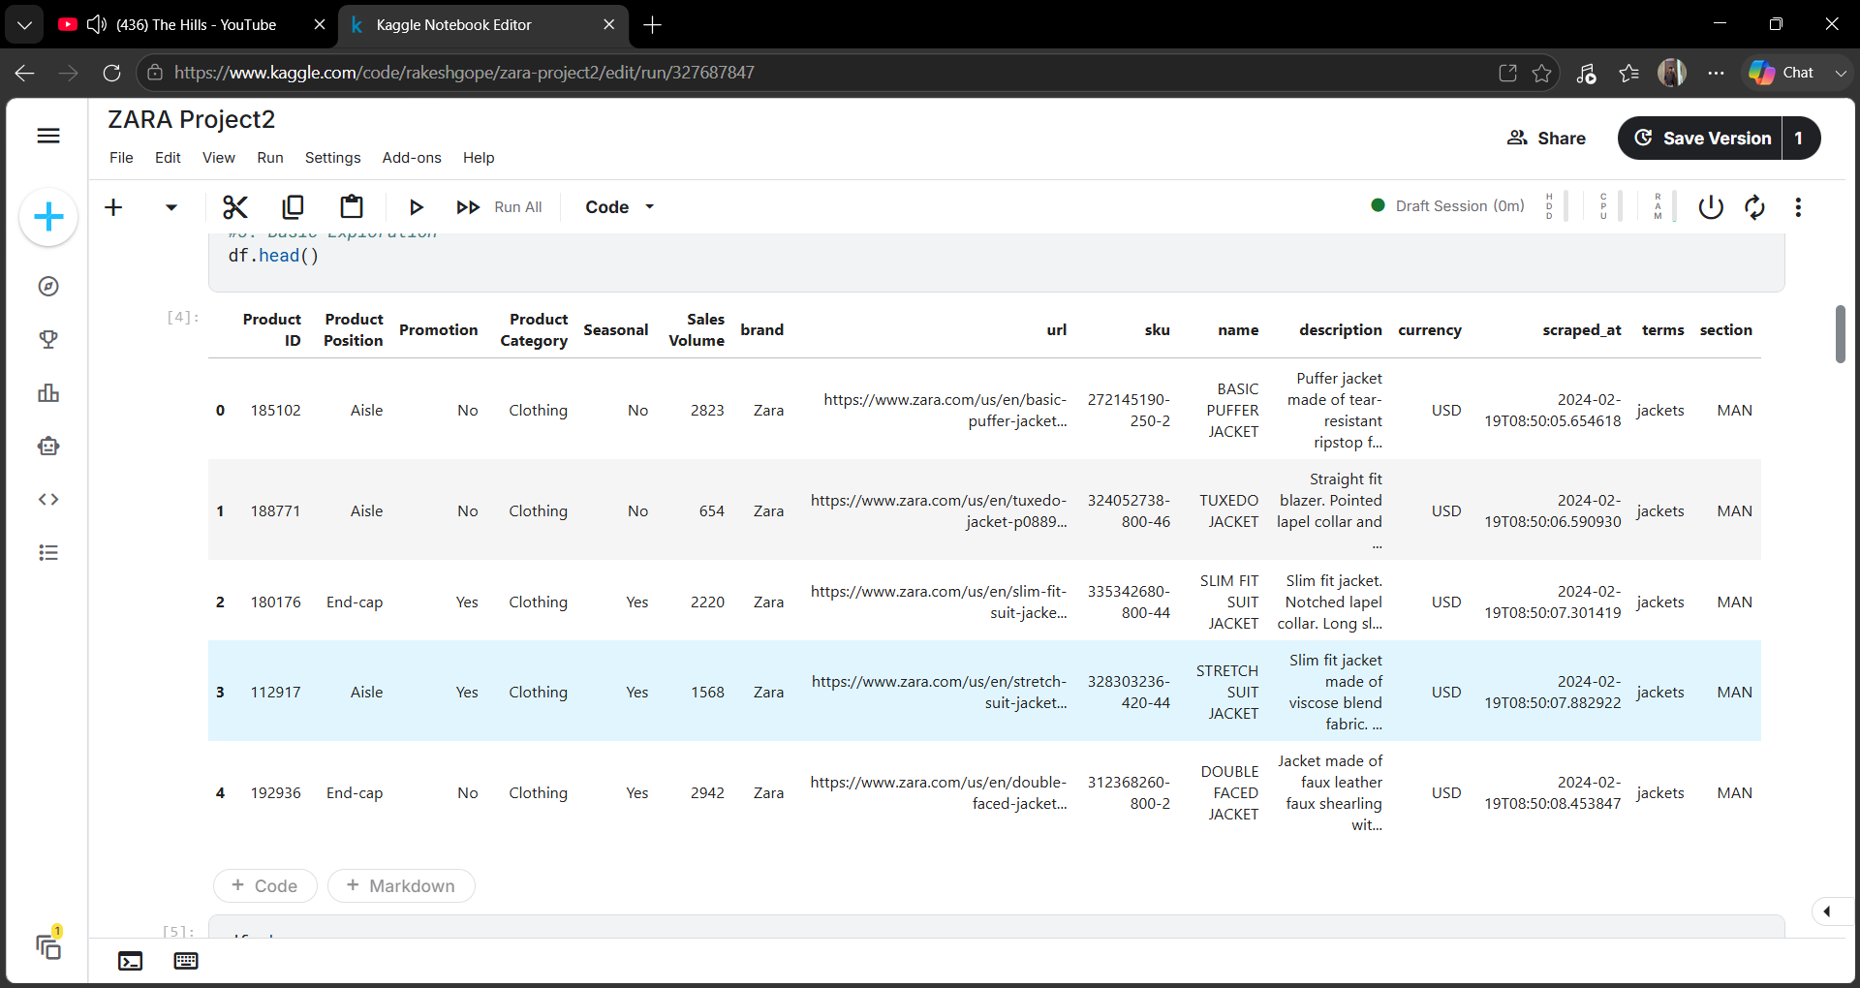

Data Quality Checks
- Checked duplicate records.
- Examined missing values.
- Reviewed sales volume distribution.
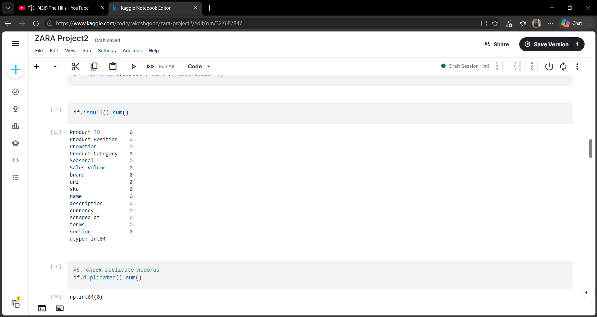
- Investigated potential outliers using IQR method.
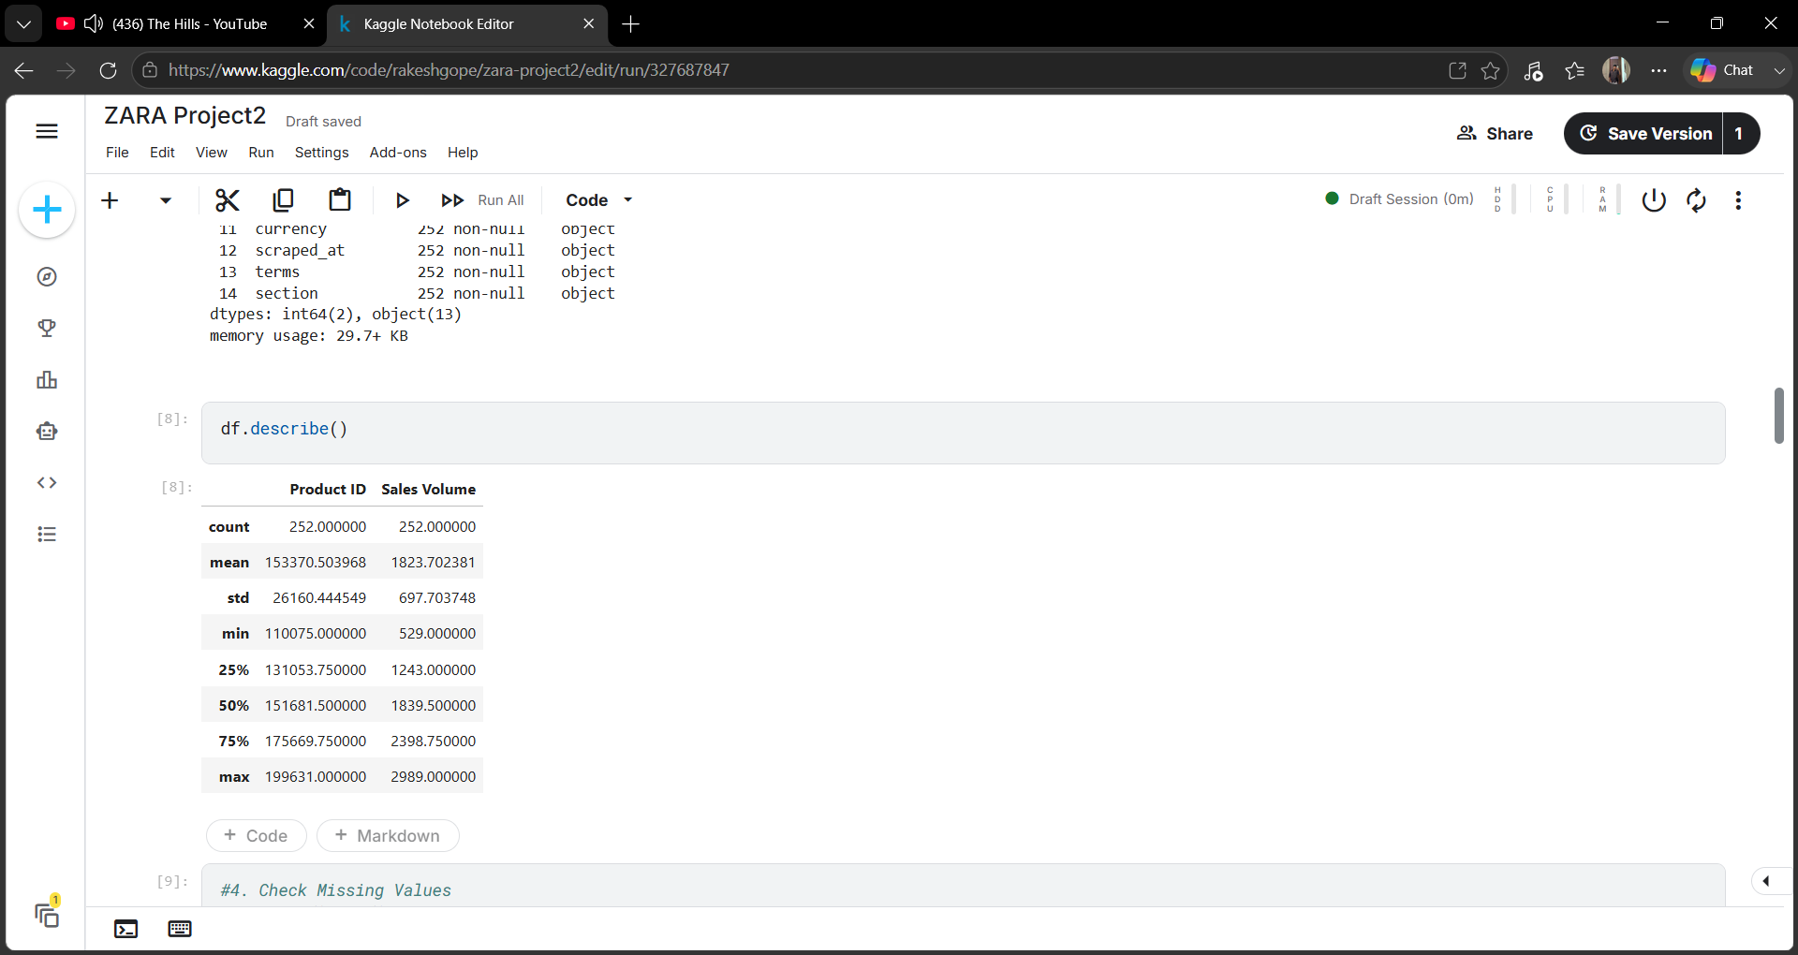

Feature Engineering
Additional fields were created for easier analysis:
- Promotion Flag
- Seasonal Flag
- Sales Category
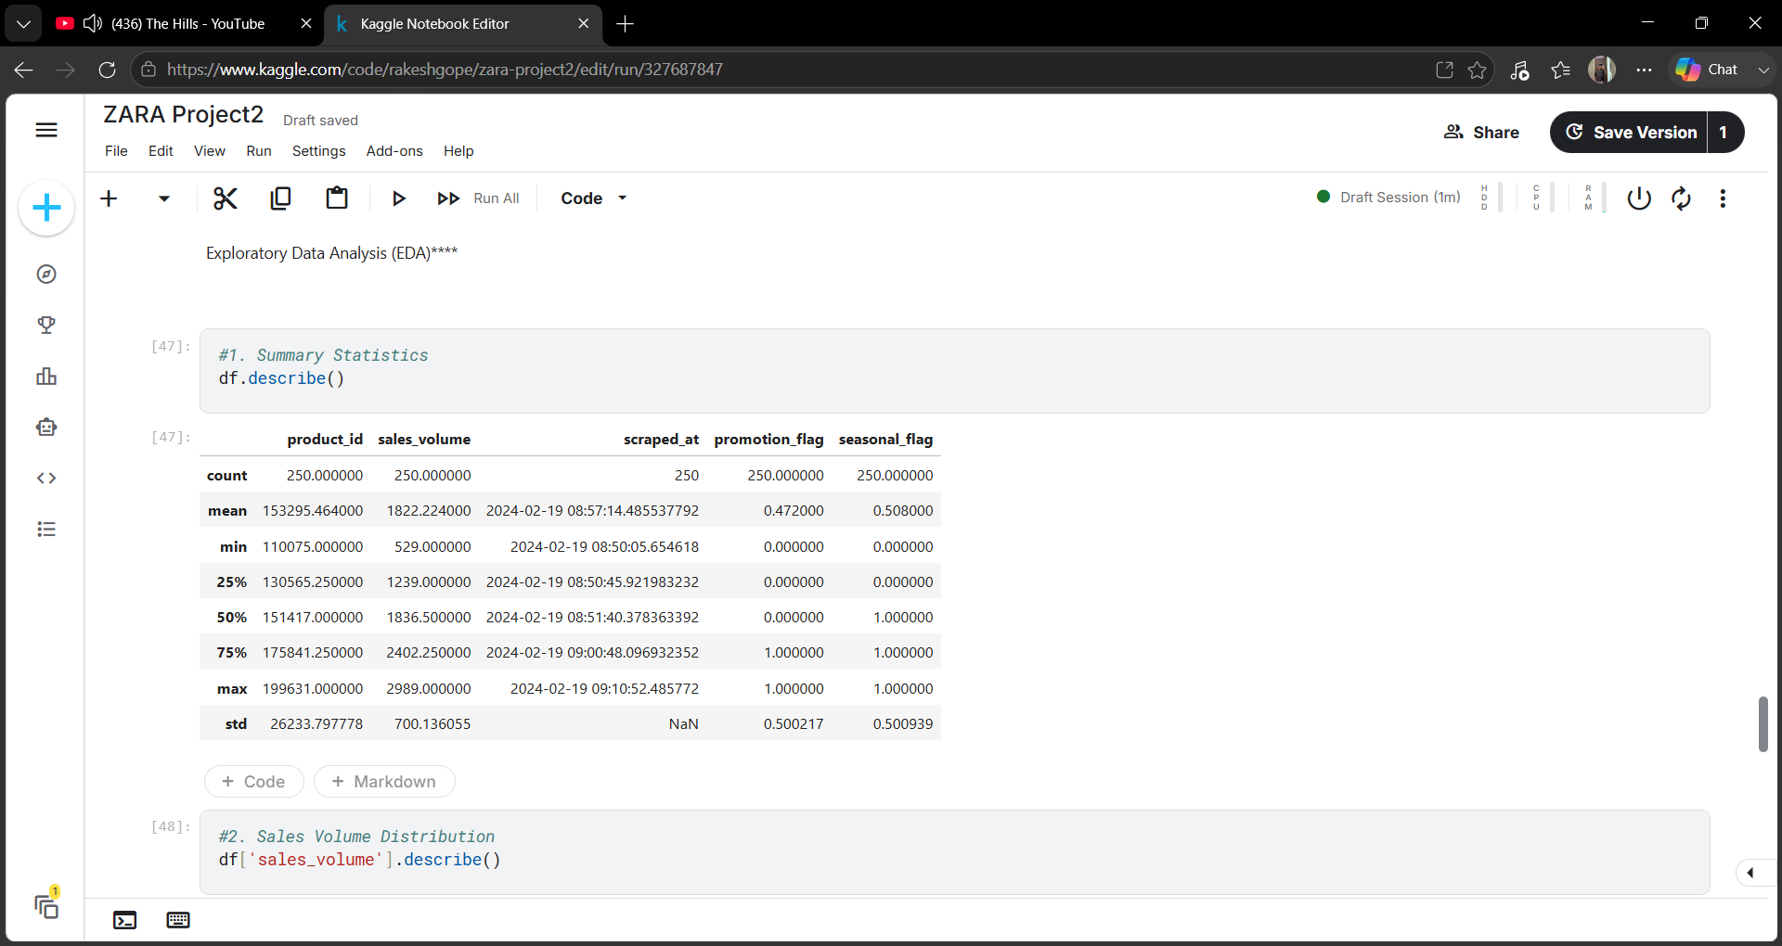
The cleaned dataset was exported as:
zara_sales_cleaned.csv

6. SQL Analysis (BigQuery)
The cleaned dataset was uploaded into Google BigQuery for analytical querying.

Analyses Performed

Top-Selling Products
Identified products with the highest sales volume.
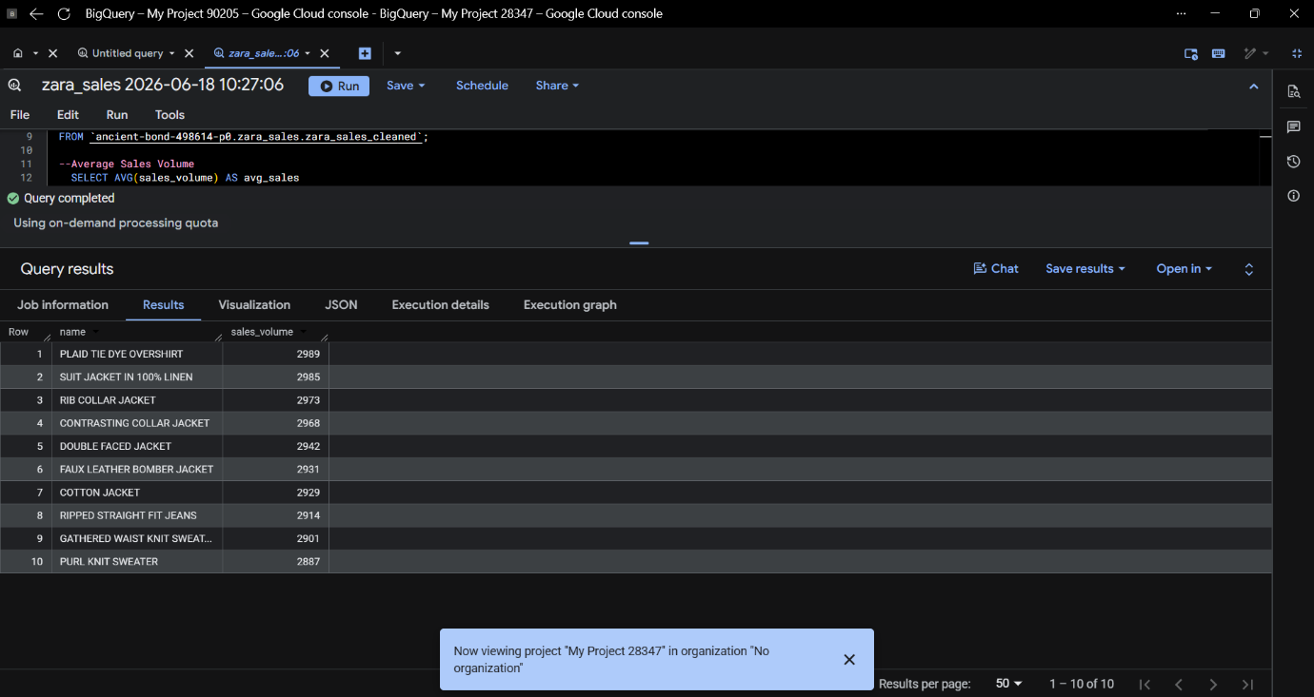

Promotion Effectiveness
Compared average sales volume between promoted and non-promoted products.
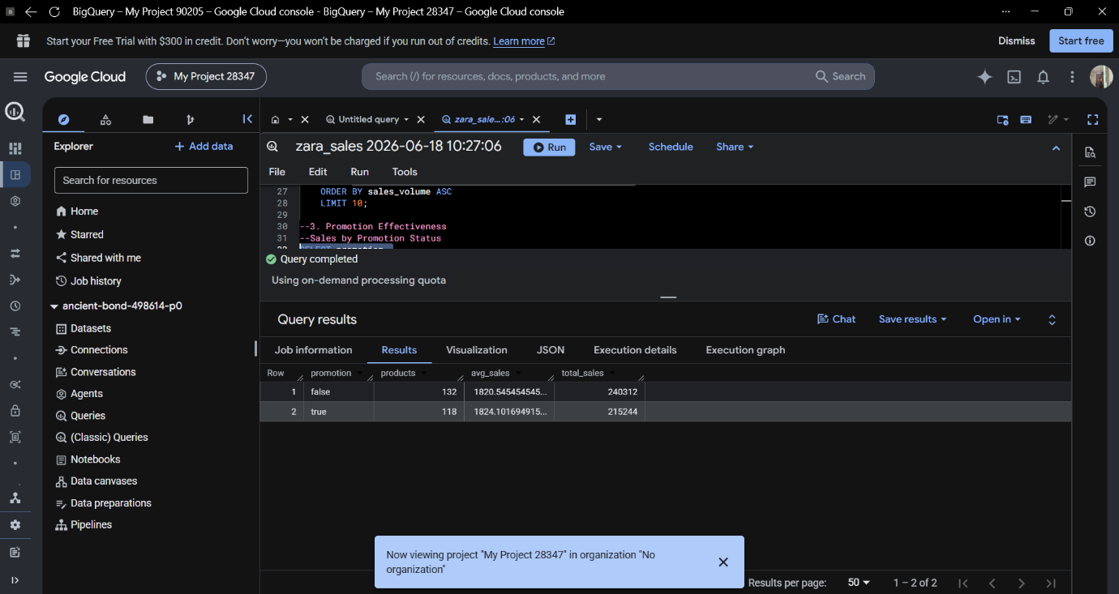

Product Position Analysis
Evaluated sales performance based on product placement:
- Aisle
- End-cap
- Front of Store

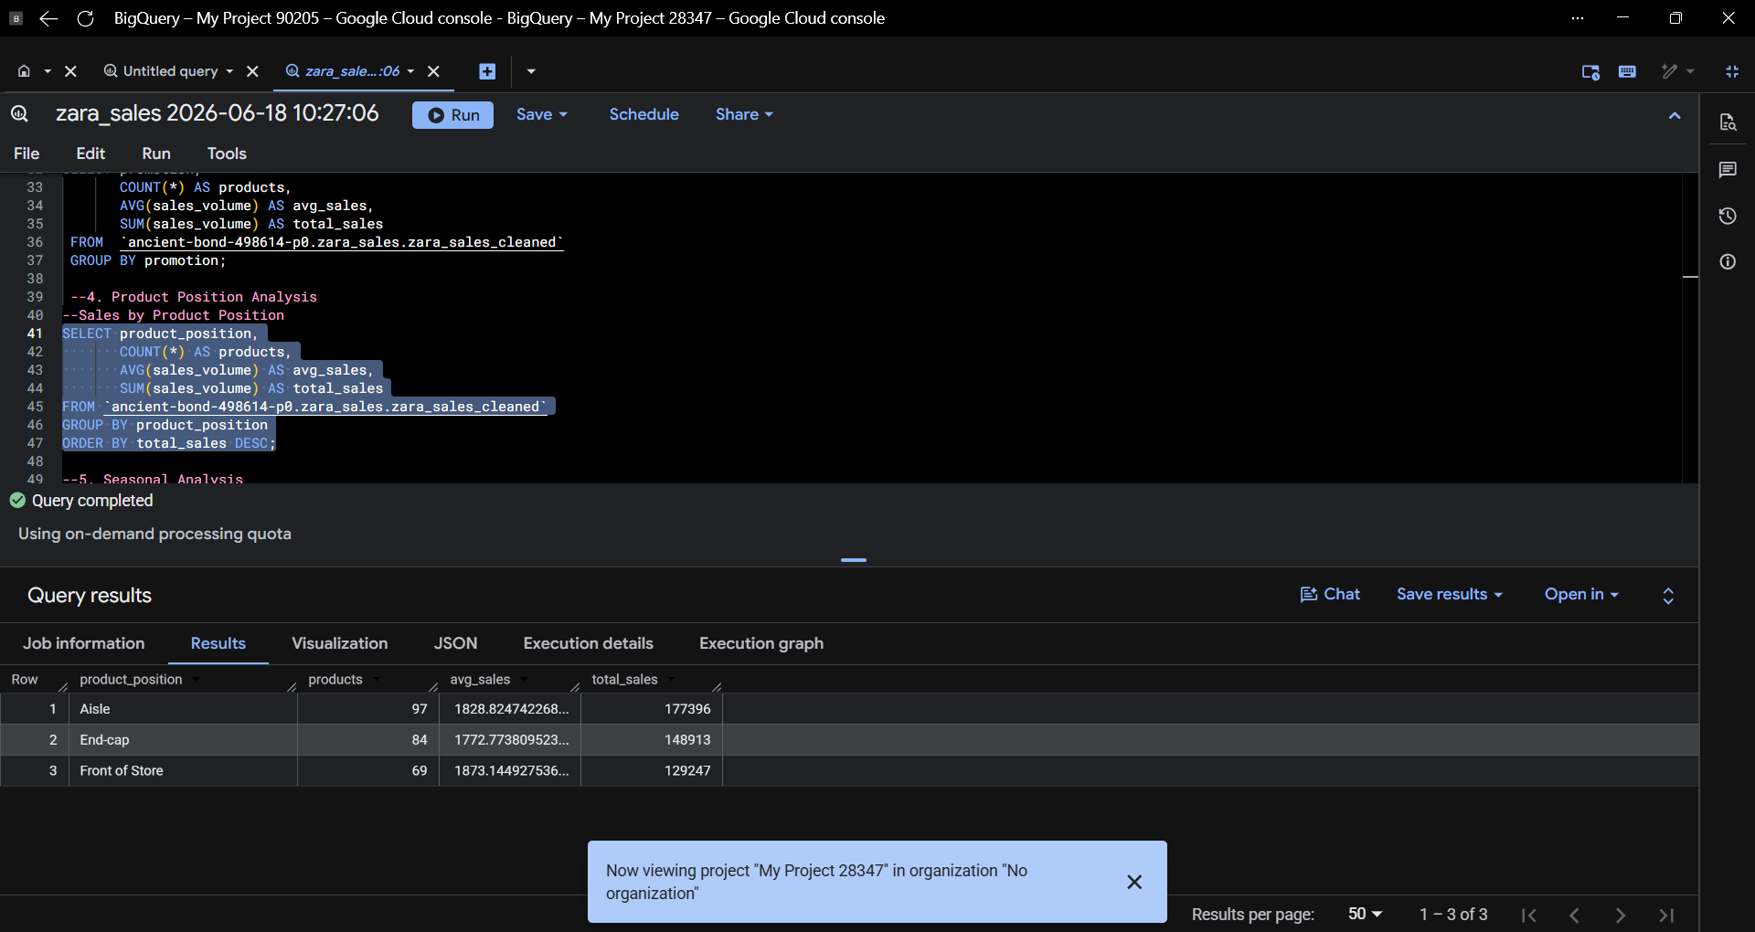

Seasonal Analysis
Compared sales contribution of seasonal and non-seasonal products.
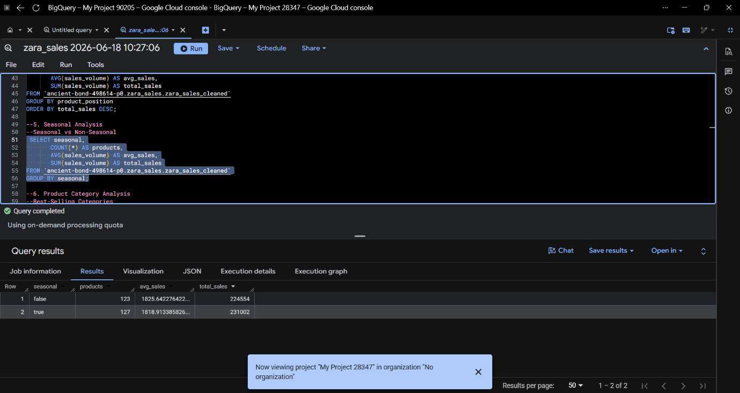

Product Category Analysis
Analyzed sales volume across categories such as:
- Jackets
- Sweaters
- Shoes
- T-Shirts
- Jeans
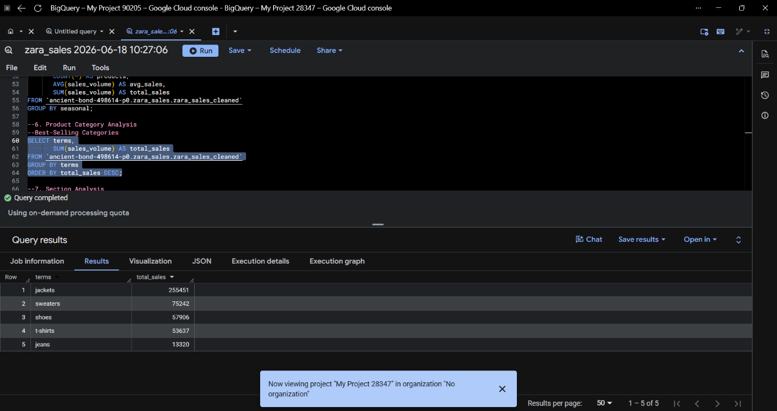

Section Analysis
Compared performance between:
- Men
- Women
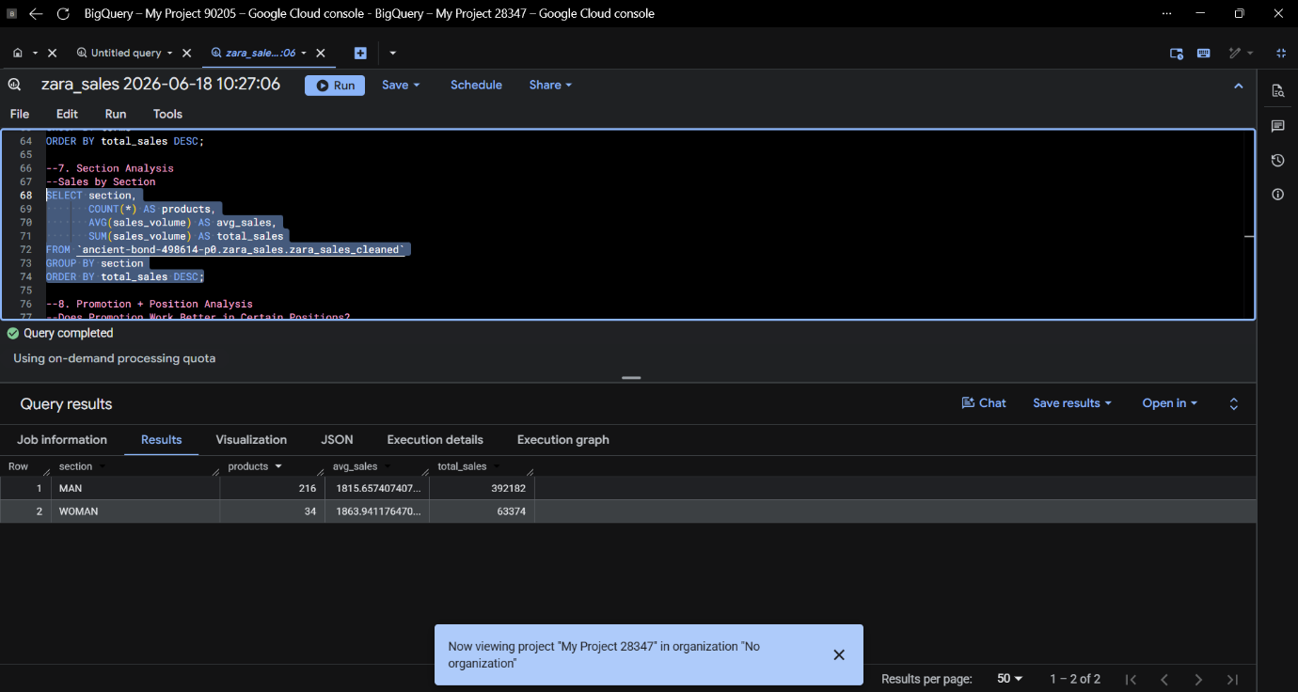

7. Power BI Dashboard
An interactive dashboard was developed in Power BI to visualize key business metrics and trends.
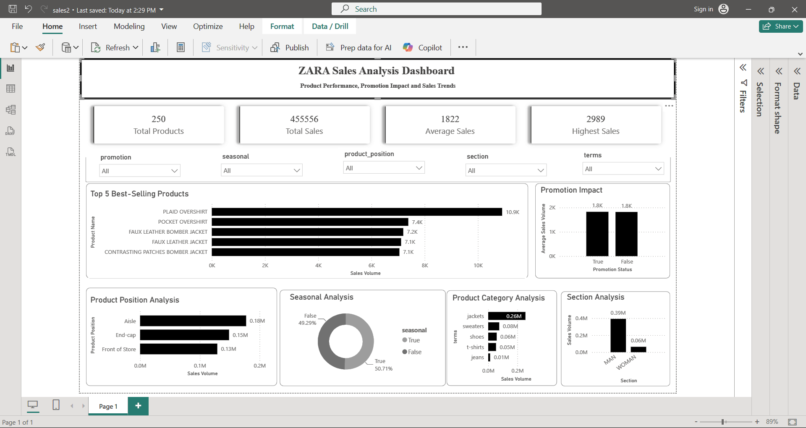

Dashboard Components

KPI Cards
- Total Products
- Total Sales
- Average Sales
- Highest Sales

Interactive Filters
- Promotion Status
- Seasonal Status
- Product Position
- Section
- Product Category

Visualizations
- Top 5 Best-Selling Products
- Promotion Impact
- Product Position Analysis
- Seasonal Analysis
- Product Category Analysis
- Section Analysis
The dashboard enables stakeholders to interactively explore sales performance across different business dimensions.

8. Key Findings

1. Top Product Performance
The Plaid Overshirt emerged as the highest-selling product with approximately 10.9K sales volume.

2. Promotion Impact
Promoted and non-promoted products generated nearly identical average sales volumes (~1.8K).
This indicates that promotions had limited influence on overall product sales.

3. Product Position Performance
Products placed in the Aisle generated the highest sales volume.
Front-of-Store products produced the lowest sales among the analyzed positions.

4. Seasonal Analysis
Seasonal and non-seasonal products contributed almost equally to total sales, suggesting limited seasonality impact.

5. Product Category Performance
Jackets were the highest-performing category, generating the largest sales volume.
Jeans contributed the lowest sales volume among analyzed categories.

6. Section Performance
The Men's section significantly outperformed the Women's section and accounted for the majority of total sales.

9. Business Recommendations
Based on the analysis, the following recommendations are proposed:

Product Strategy
- Increase inventory for high-performing products such as jackets and top-selling overshirts.
- Review underperforming categories and consider assortment optimization.

Merchandising
- Prioritize aisle placement for products with high sales potential.
- Reassess front-of-store placement strategies.

Promotion Strategy
- Conduct deeper promotional testing since current promotions show minimal impact on sales.
- Explore personalized promotional campaigns.

Inventory Planning
- Focus inventory investment on consistently high-performing categories.
- Monitor low-performing categories for potential discontinuation or redesign.

Customer Segmentation
- Further investigate customer preferences by section and category to support targeted marketing efforts.

10. Conclusion
This project successfully utilized Python, SQL, and Power BI to transform raw sales data into meaningful business insights. The analysis identified key sales drivers, highlighted top-performing products and categories, and evaluated the effectiveness of promotions and product placement.
The developed dashboard provides an interactive decision-support tool that enables stakeholders to monitor performance and make informed business decisions. The findings can help Zara optimize merchandising strategies, improve inventory planning, and enhance overall sales performance.

Technologies Used
- Python (Pandas, NumPy)
- Google BigQuery (SQL)
- Power BI
- Microsoft Excel

Project Deliverables
- Cleaned Dataset
- Python Data Preparation Notebook
- SQL Query Scripts
- Power BI Dashboard (.pbix)
- Project Report
- Presentation Slides
- GitHub Repository

